Chapter 5 Quest Study Guide Continued…

How cells were first discovered

1. In 1590 the first ____microscope_____________________was invented.
2. In 1663 Robert Hook observes the bark of the cork oak tree and names what he sees ___cells______________.
3. Anton Van Leeuwenhoek is the first to see __animal___________________cells.
4. In 1838 Matthias Schleiden concludes that all __plants________are made of cells
5. In 1939, Theodore Schwann concludes that all _____animals______________are made of cells.
6. In 1855 Rudolf Virchow proposes that new cells are formed from cells that __already exist.

All these discoveries led to the formation of Cell Theory

1. A Theory is an ___explanation___________________________ of what we observe
2. Theories are based on many _observations__________________________and are ___accepted________________ by many people.
3. Three Parts of Cell Theory:
4. All ____living things______________ things are composed of cells.
5. Cells are the basic units of ___structure_______________ and ______function____________ in living things
6. All Cells come ________from___________ _________other____________ cells.

Turn to a Partner and share*! What do microscopes allow us to do?*

1. A microscope ___focuses______________ _______light__________ through lenses to produce a magnified image.
2. 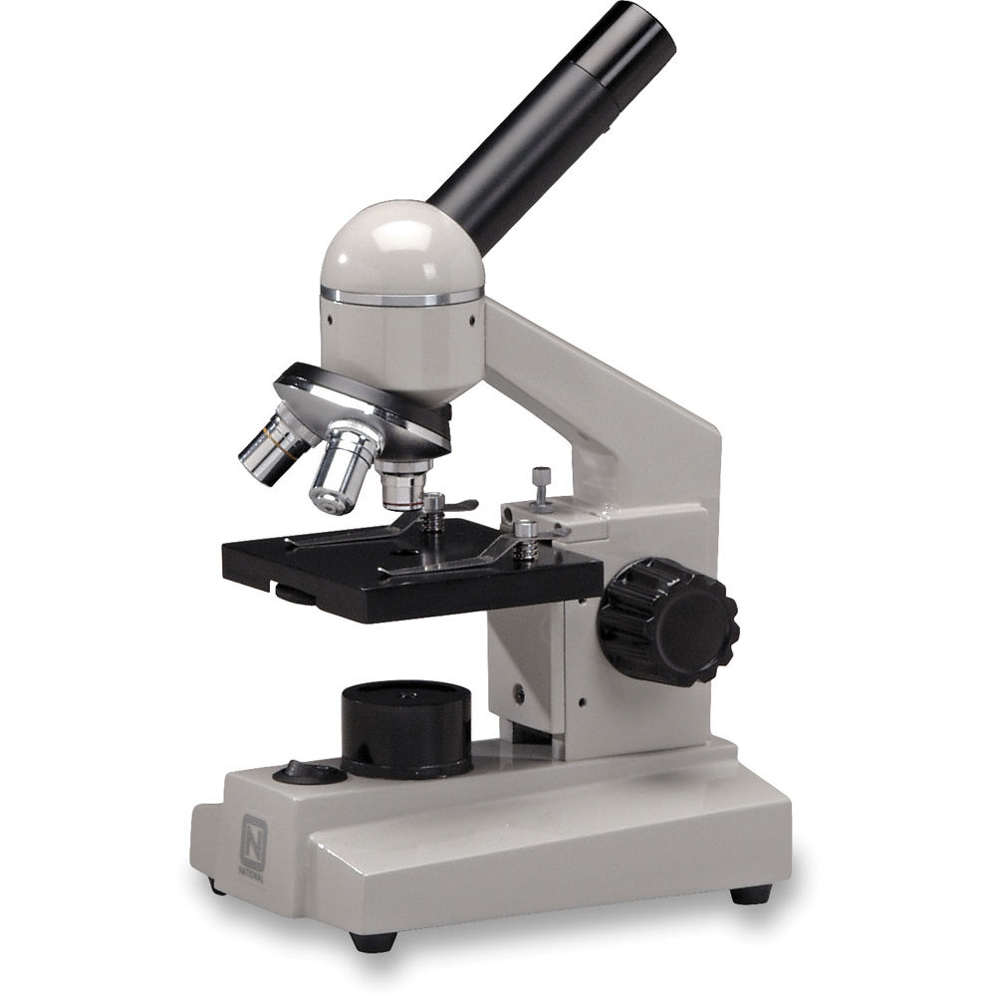Magnification is the condition of things appearing ______larger_____________ than they are.

In a microscope there are two lenses:

1. The first lens is in the __eyepiece____________________.
2. The second lens is on the __nose________________ piece.
3. In a microscope total magnification is the power of lens 1 multiplied by the power of lens _2_____.
4. Resolution describes the degree to which two _____different____________ __objects___________________ that are close together can be distinguished.
5. The greater the resolution, the more ______detail__________.

Organelles

1. Mitochondria
2. Lysosomes
3. Vacuoles
4. Golgi Apparatus
5. Cytoplasm
6. Nucleus
7. Cell Wall
8. Chloroplast
9. Cell Membrane
10. Ribosomes
11. Endoplasmic Reticulum

**Organelle Function**

1. _g____Rigid layer that provides protection and support to a cell
2. **_i____ controls which substances pass into and out of a cell.**
3. _f___Cell’s Brain, Controls a cell’s activities
4. **___j__ produces proteins.**
5. **__e___** Clear, gel-like fluid that cell’s sit in
6. **___a__ Changes food into usable energy.**
7. **__k___** proteins and sends them throughout the cell.

**8. __d___Accepts proteins from the endoplasmic reticulum**

**9. __c___a pocket that stores food, water, waste, and other materials**

10. **__h___**Captures energy from the sunlight and changes it into energy

**11. __b___ Organelles that break large food particles down into smaller ones.**

**Label the Nucleus, Mitochondria, Ribosomes, Lysosomes, Rough Endoplasmic Reticulum, Golgi Apparatus, and Vacuole**

**Nucleus**

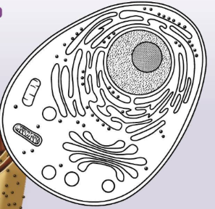

**Ribosome Rough Endoplasmic reticulum**

**Mitochondria Golgi Apparatus**

**Lysosome Cell Membrane**